**Predicting job creation in Colombian cities with key economic, social, or demographic information**

**Subtitle**

Supervised by

**Prof. Dr. Simon Munzert**

Professor of Data Science and Public Policy | Director, Data Science Lab

**Alvaro Jose Guijarro May**

Master of Data Science for Public Policy

2024

**Word count:**

**HERTIE SCHOOL**

Berlin, Germany

*If man can predict, almost with certainty, those appearances of which he understands the laws; if, even when the laws are unknown to him, experience of the past enables him to foresee, with considerable probability, future appearances; why should we suppose it a chimerical undertaking to delineate, with some degree of truth, the picture of the future destiny of mankind from the results of its history?*

(De Condorcet, 1795)

*Para Rita, Alvaro, Camilo y Coco. Valió la pena.*

Table of Contents

**1.** **Introduction** 4

**2.** **Literature review** 5

**2.1 Do local factors have an effect on employment growth?** 5

**2.2 Cities development metrics** 5

**2.3 Economic growth forecast** 5

**3. Methodology** 5

**3.1 Data** 5

**3.2 Preprocessing** 6

**3.3 Models** 6

**3.4 OLS /Arima / Sarima / Random Forrest** 6

**4. Results** 6

**5. Discussion** 6

**5.1 Limitations** 6

**5.2 Future Work** 7

**6. Conclusion** 7

**7. Bibliography** 7

**8. Statement of Authorship** 7

# **Introduction**

Public administration and its effects have been evolving in parallel with the societies it has been affecting. At the beginning of the XX century, Max Weber highlighted the necessity of a stable distribution of official labors with the end goal of achieving public objectives in his studies about the rationalization of bureaucracy. He also insisted on the importance of stablishing a system of rules that clearly specifies the authorities in charge of carrying out said duties, its corresponding functions, and the coercive methods available to guarantee effective policy management (Weber, 2024). He laid out the foundations on which the measurement of public policies was built upon.

Colombia is a social State under the rule of law, structured under the category of a Unitary Republic, whose central authority is the President of the Republic. Its territorial organization has four autonomous territorial divisions: departments, districts, municipalities, and indigenous territories. The municipalities are the primary and essential units of the territorial organization and, together with the departments, enjoy autonomy, based on the decisions that the decentralized regime allows their local authorities to make (Asamblea Nacional Constituyente, 1991). Each municipality must offer the public services established by law, develop the necessary infrastructure for local progress, plan the growth of its territory, foster community participation, and improve the social and cultural welfare of its residents.

Mayors are conceived in Colombia as heads of local administration, legal representatives, and first political authority (Congreso de la República de Colombia, 1994) as well as the police authority of the municipality. They are democratically elected for four-year terms, without the possibility of reelection (Asamblea Nacional Constituyente, 1991). By virtue of their role as authorities with constitutional functions, mayors act as economic agents, making decisions on the demand and supply of goods and services within their territories and as joint representatives of the authorities of the governors and presidents, who in turn define the policies for the regulation and promotion of labor in Colombia (Dorado, 2021). They must direct the administrative action of their municipalities, ensuring the provision of public services and the proper functioning of local industrial or commercial enterprises. In order to determine their actions and decisions, they must present plans and programs for economic and social development, consistent with municipal expenditure and investment, collection, and budget plans (Asamblea Nacional Constituyente, 1991).

Government officials have the opportunity to guide their communities positively, or negatively, and affect the lives of their citizens with their public policy priorities, implementations, and executions. Leaders specially have the capacity of affecting economic growth in their countries (Jones & Olken, 2005). The actions taken during their administrative periods have effects on current and future economic, social, and demographic metrics, and this relationship is not exclusive for one community; any society that has this type of government structure has and will experience it (Jones & Olken, 2005). A way of determining how positive or negative the performance of public officials has been on their societies is to evaluate key metrics that track important development factors through time. Being able to measure their overall performance can help public official to “evaluate, control, budget, motivate, promote, celebrate, learn, and improve”(Behn, 2003). This paper will look to evaluate if the evolution of key economic, social, or demographic metrics in Colombian cities can be used to predict economic wellbeing in said locations, reflected in citizen’s employment levels in the formal economy.

# **Literature review**

## **2.1 Do local factors have an effect on employment growth?**

There have been previous attempts to try to quantify the effects social, demographic, economic, or geospatial factors have in local employment growth, like the research conducted by Richard Shearmur and Mario Polèse, in which they analyzed the impact of local and structural factor on employment growth in Canada (Shearmur & Polèse, 2007). By analyzing why employment growth occurs on some regions of the country and not in others, they were able to determine that “local (endogenous) and structural (exogenous) factors retain significant explanatory power”(Shearmur & Polèse, 2007) regarding employment growth. Some of the factors used in this study were education levels, population growth, workers’ wages, and geographic locations of Canadian regions.

The International Monetary Fund has pointed out that job growth and creation are within countries and cities top priorities, but the outlook for growth and creation remain as an important concern (International Monetary Fund, 2013). The set of forces that influence growth and job creation in developing countries in recent decades are technological change, demographic changes, poverty rates, GDP, income inequality, and fiscal maneuverability (International Monetary Fund, 2013).

In the Colombian context, researchers have looked into the effect in employment rates and the economy from fiscal policies (Gerardo et al., 2014), educational and health reforms (Martínez-Álvarez, 2015),

**2.2 Cities development metrics**

## **2.3 Economic growth forecast**

# **3. Methodology**

## **3.1 Data**

As of 2019, Colombia had a population of around 49 million people, distributed in 32 states and 1103 municipalities (DANE, 2019). 21 million people, or around 45% of the total population of the country is distributed along its 13 biggest cities and their metropolitan areas (referred to as “A.M” for their Spanish definition of “Area Metropolitana”). These are: Bogota A.M., Medellín A.M., Cali A.M., Barranquilla A.M., Cartagena, Cúcuta A.M., Bucaramanga A.M. Villavicencio, Ibagué, Monteria, Pereira A.M., Manizales A.M, and Pasto. The following map shows the distribution of these cities on the Colombian territory with their official names:

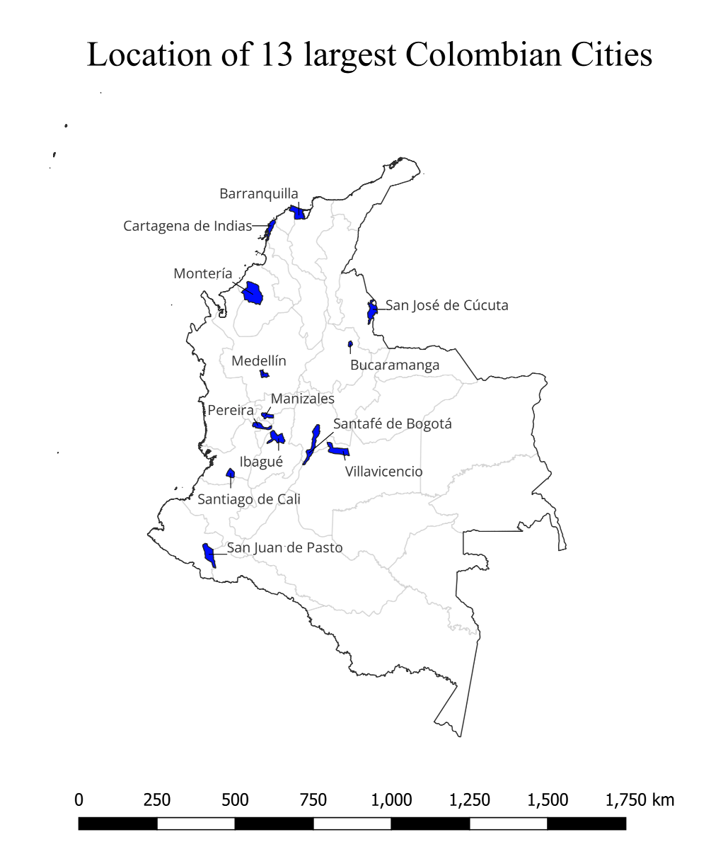

Figure 1. Map of Colombian Cities

The country’s unique socio-economic landscape has changed through the years by various demographic, political, economic, geospatial, and social factors. Most of the population has historically been based in the center of the country, some 2,625m above sea level in the capital city of Bogotá A.M. in the Andes mountains, with other population centers scattered throughout the country’s diverse landscape. Here, each city has found their own cultural, economic, and industrial identity, and has managed to provide stability and community for their local populations. Bogotá A.M. and Medellín A.M. are considered the commercial and administrative centers of the country, with Barranquilla A.M. and Cartagena being major port cities filled with trade, industry and tourism, Pereira A.M., Manizales A.M., and Ibagué focusing on coffee and rich agricultural activities, in addition to Cali A.M. and Bucaramanga concentrating on manufacturing and industrial activities. Each city has had its own population evolution during the last decades, and this has also affected their job markets. In the following plot we can observe the evolution of employed citizens vs population growth of each city.

* + Grafica con evolución de la población en estas ciudades y # de trabajadores ocupados.
    - Hacer un plot de 4 x 3, en el que se vea para cada ciudad, la evolución de la población vs los trabajadores. / 2010 hasta 2019.
* Gran Encuesta Integrada de Hogares
* Population data, dane
* Consumer Price Index
* Education
* Monetary Poverty
* MDM Cities Indicators
* Fiscal Performance Amounts
* Fiscal Performance Scores
* Reasoning behind selecting these datasets, effect of public policy in indicators (buscar Fuente)

## **3.2 Preprocessing**

* Defining timeframe
* Frequency transformation (Spline Interpolation)
* Scaling variables

## **3.3 Models**

* Difference between linear regression models, time series models, machine learning approaches.

## **3.4 OLS /Arima / Sarima / Random Forrest**

* What is an OLS Model
* What is an Arima Model
* What is a Sarima Model
* What is a Random Forrest
* Fitting the models and importance of comparing

# **4. Results**

* Explanation of Result Metrics

**4.1 Overall Results**

* Table with results for 13 cities, OLS, ARIMA, SARIMA Results, Random Forrest results

**4.2 City Specific Results**

* Examples of prediction for Bogota, Barranquilla, and Medellín.

# **5. Discussion**

## **5.1 Limitations**

* Complexity of variable y prediction
* Limitations in current available data
* Interpolation and transformation
* Descriptive analysis only, causation component needs to be explored

## **5.2 Future Work**

* Identifying more suitable models
* More precise and trustworthy Data gathering
* City specific, Economic Sector Specific

# **6. Conclusion**

* Prediction is possible but complex.
* Correlation does not mean causality
* Public policy must be based on empirical data, and decisions have to be made according to facts but guided by continuous improvement.
* Public officials have the responsibility and duty of fostering an air of improvement, possibilities, and wellbeing in their jurisdiction, and must have plans in place that will lead to this.

# **7. Bibliography**

Asamblea Nacional Constituyente. (1991). *Constitución Política de Colombia de 1991.* Imprenta Nacional.

Behn, R. D. (2003). Why Measure Performance? Different Purposes Require Different Measures. *Public Administration Review*, *63*(5), 586–606. https://doi.org/10.1111/1540-6210.00322

Congreso de la República de Colombia. (1994). *Ley 136 de 1994*.

DANE. (2019). *PROYECCIONES DE POBLACIÓN A NIVEL MUNICIPAL. PERIODO 2005—2019.* [dataset].

De Condorcet, M. (1795). Future progress of mankind. In *Outlines of an historical view of the progress of the human mind: Being a posthumous work of the late M. De Condorcet.* (pp. 316–372). J Johnson. https://doi.org/10.1037/11670-010

Dorado, D. (2021). *El Rol del Alcalde en el Desarrollo de los Mercados*.

Gerardo, C.-T., Robinson, C.-Á., & Asdrúbal, R.-M. (2014). *Impact of fiscal policy on savings and employment in colombia (1970-2011)*. *21*.

International Monetary Fund. (2013). Jobs and Growth—Analytical and Operational Considerations for the Fund. *Policy Papers*, *2013*(18). https://doi.org/10.5089/9781498342148.007

Jones, B. F., & Olken, B. A. (2005). *DO LEADERS MATTER? NATIONAL LEADERSHIP AND GROWTH SINCE WORLD WAR II*.

Martínez-Álvarez, J. J. (2015). *IMPACTO DE LAS REFORMAS ECONÓMICAS NEOLIBERALES EN COLOMBIA DESDE 1990.* *8*(1).

Shearmur, R., & Polèse, M. (2007). Do Local Factors Explain Local Employment Growth? Evidence from Canada, 1971–2001. *Regional Studies*, *41*(4), 453–471. https://doi.org/10.1080/00343400600928269

# **8. Statement of Authorship**